P2 OBD LCD Head up display
(P2 has registered appearance patents in many countries and display screen copyrights)

Description of the Interface and Button
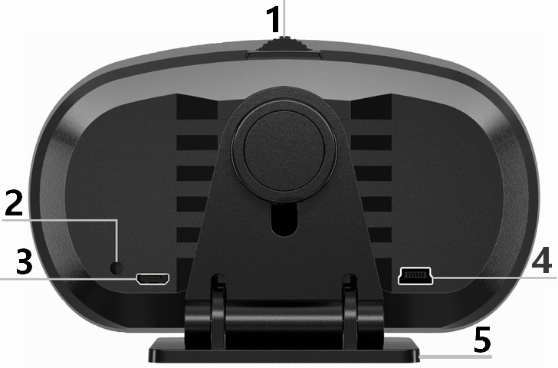

- Main button: Short press in Long press in
Short push left Long push left
Short push right Long push right
- Light Sensor: Automatically adjusts the brightness according to the environment
- Alternate interface
- OBD cable interface
- Rotatable bracket

Description of the Button
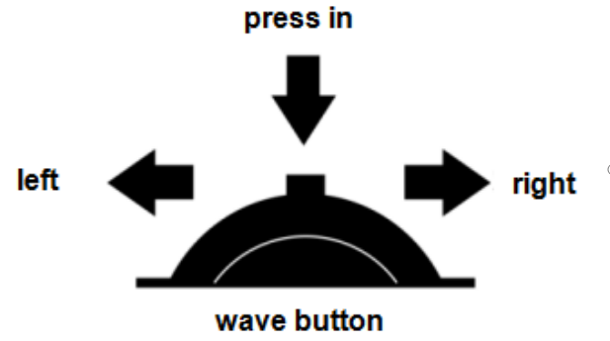
- Short press in(1s to release）: A.Switch display interface
B.Short press to confirm
- Long press in（2s to release）：Enter setting mode, again to save
and exit
- Long push left（2s to release）：Long push left and the icon will
flash, indicating that this functional area is selected, can switch and select this functional area ( PS: It will be automatically saved if no operation after 10s.)
- Short push left: A.Toggle the blinking ribbon position
B.Move options/adjust values after entering setting mode
5.Short push right： A.Toggle the display function where the
icon flashes
- Move options/adjust values after
entering setting mode
6.Long push right： Quick switch on/off

Switch GPS system
A. Plug in the USB cable, the device will automatically enter the GPS system
B. Plugging in the OBD cable, long press into enter setting mode，find “OBD Switch”, then select “OFF”

Quick shutdown
Long push right to quick shutdown and boot

Slope meter calibration:
Place the device well, turn off the car and the screen will shut down, then start the device again, and the calibration is complete

Switch function icon
Long push button, main interface icon flashes,
then short push left to switch icon，
short push rightto switch function，short press in to confirm( Will automatically exit after 5 seconds of no operation)

 | Voltage |  | Instant fuel consumption |  | Power battery power |  | Driving distance
 | Water temperature |  | Average fuel consumption |  | hydraulics pressure |  | Driving time
 | Oil temperature |  | Engine load |  | Fuel pressure |  | Rotating speed
 | Transmission oil temperature |  | Exhaust gas temperature |  | Altitude |  | Speed
 | Turbo pressure |  | Oil quantity |  | Clock |  | Driving direction
 | Atmospheric pressure |  | Tilt left and right |  | Tilt up and down |  | OBD speed

Function explanation
Speed= Speed | VLT= Voltage | Coolant= Coolant temperature
OIL T.= Oil temperature | CVT= Transmission oil temperature | TURBO= Turbo pressure
INS Fuel= Instant fuel consumption | AVG Fuel= Average fuel consumption | EGT= Exhaust gas temperature
FUEL LEV.= Fuel quantity | DriveDist= Driving distance | DriveTime= Driving time
Altitude= Altitude | GPS NumSv= Satellites number | TACHO= Rotating speed
GPS Speed= GPS Speed | I.A.T.=Intake air temperature | OIL P.=Hydraulics pressure
FUEL P.=Fuel pressure | GPS Offst=GPS precision | Date= Date
Week=Day of the week | Time=Time | G-Force=Accelerometer
LAT=Latitude | Atmospher=Atmospheric pressure | LON=Longitude
Direction=Driving direction | ENGINE Ld=Engine Load | Outside Temp=Outside temperature
HybridEle.=Power battery power | G-Roll A.=Left and right tilt angle | G-Pitch A=Front and rear pitch angle

Enter setting mode:
Long press into enter the setting mode，push rightto select setting item，short press into enter the setting item，after adjustment long press into save，again to save and exit
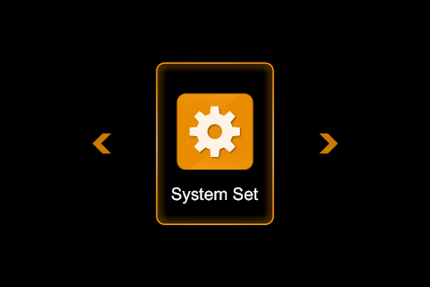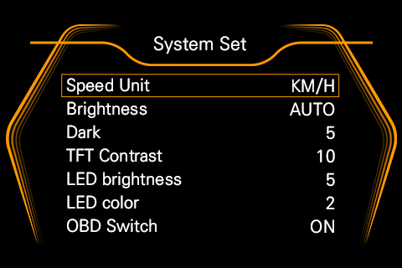
System Set | System setting
Time Zone | Time adjustment | Power On | Power on method
Speed Unit | Speed unit | Power Off | Power off method
Brightness | Brightness adjustment | LED Color | Atmosphere light color
Dark | The darkest brightness | Turn Off | Turn off voltage
TFT Contrast | Contrast | Quest Mode | Communication mode
LEDBrightness | Atmosphere light brightness | Request Rate | Communication speed
LED Dark | Brightness at night | ValueSmooth | Speed of digital change
LED Color | Color of atmosphere light | Demo | Display mode
OBD Switch | OBD switch | Clear DTC | Clear fault code
Comd Search | Search PID instruction | Factory Set | Factory setting

Special Fea | Special feature
Model | Model | Fuel T. | Fuel temperature
Coolant T. | Coolant temperature | Outside T. | Outside temperature
Oil T. | Oil temperature | I.A.T. | Intake air temperature
AT Oil T. | Automatic transmission oil temperature | Catalyst T. | Catalyst temperature

Speed set | Speed setting
Speed Choice | Speed choice | Speed Warning | Speed warning

ADJUST | Data adjustment
Speed Adjust | Speed adjustment | Fuel Adjust | Fuel adjustment
RPM Adjust | RPM adjustment | Voltage Adjust | Voltage adjustment
Turbo Adjust | Turbo adjustment

FUEL Set | Fuel setting
Fuel Unit | Fuel unit | Fuel Type | Fuel type
Fuel Calcu | Fuel calculate | Swept Volume | Engine swept Volume

ALARM | Alarm setting
Alarm Switch | Alarm switch | OIL P. Alarm | Oil pressure alarm
RPM Alarm | RPM alarm | Fuel P. Alarm | Fuel pressure alarm
Coolant Alarm | Coolant temperature alarm | Voltage Alarm | Low voltage alarm
Oil Temp Alarm | Oil temperature alarm | Rest Alarm | Rest alarm
EGT Alarm | Exhaust temperature alarm

FAQ
1.No display on the screen, no power
Check whether the OBD cable is loosely connected, try to connect it several times. If it still does not work, please change another car to test, and analyze whether the OBD interface of the car is broken. If the OBD interface is broken, please repair the OBD interface and then connect the machine again.

- Powered on, but P2 only displays voltage, and automatically turn off after 30 seconds
OBD device are only suitable for OBDII and EOBD
Please check the year of car production (OBDII and EOBD were used after 2008)
HUD products do not support OBD I and JOBD, and the cars produced before 2008
Please connect directly with a USB cable.

3.The speed display on P2 is different from the instrument panel’s
Please check if the unit is correct: kilometer-KM/mile-MPH( Speed unit switching reference setting item).
If the unit is correct: please long press in to enter the setting mode, choose “Adjust” and select “SPEED Adjust” (For example: the instrument displays 100 Km/h and the device displays 102 Km/h, adjust the parameter value to -2%).
- Can't power on with car
Enter setting mode, find “Power On”( The default is to automatically power on when the voltage exceeds 0.8V ), please adjust the value to 0.5V or 0.4V.
PS: Setting the voltage too low will cause the machine to keep restarting.

- Unable to shut down or automatically start and stop with the car( Gas-electric hybrid vehicle )
Enter setting mode, find “Power Off”
MODE 0: Judging that the communication conditions are in line with the preset, will power off in 5 seconds (suitable for most models)
MODE 1: Judging that the speed and voltage conditions of the vehicle are in line with the preset, will power off in 5 seconds (suitable for special models)
MODE 2: Special for automatic start and stop, or gasoline-electric hybrid vehicles

6.The time is not correct
Enter setting mode, find “Time Zone”to adjust the time.

